

**Department of Computer and Information Technology**

**Jaypee Institute of Information Technology, Noida**

**Web Tech Project**

www.knotmypro.esy.es

**KNOT - Social Networking Website**



**B-10**

**Submitted To: Submitted By:**

**Suma Dawn**

**Anand Kumar Tiwari - 13103445**

**Naman Singhal - 13103441**

**Sakshi Dubey - 13103716**

**Puja Kandel - 13103729**

**TABLE OF CONTENTS**

1. ABSTRACT

2. OBJECTIVS

3. LITERATURE REVIEW

4.PROJECT DESIGN

4.1Gantt Chart

4.2 Process Model

4.3 UML

4.4 Use Case Diagram

5.WORK DIVISION

6.Comparative Study with other social networking sites

7.FEATURES

7.1Home

7.2 Profile

7.3 Settings

7.4 Search

7.5 Messages

7.6 Logout

7.7 About

7.8 Friends

7.9 Requests

7.10 New Message

7.11 Username

8.ADDITIONAL FEATURES IN PHASE 2

8.1 Google Mapping

8.2Share on facebook

8.3 Videos

8.4 Game World

8.5 Galleries

8.6 Calender

9. ANDROID APP

10. INTERNAL WORKING

10.1 Php, Scrapping

10.2 Database Handling

10.3 Ajax

10.4 Facebook graph API

10.5 Google Location

10.6 Bootstrp

11 BACKGROUND STUDY AND FINDINGS

12.DESIGNING DETAILS

13. WEBPAGES

14. PROJECT FEATURES

15. REFRENCES

**1. ABSTRACT:**

This web tech project aims to develop a social networking site. This includes multiple basic options of messaging, adding friends, chatting, news feed but this is not the mere imitation of existing social media websites. It contains special some special features like embedded dictionary, map tracing, login through other social media platforms, etc. It includes basic fundamentals of php, JavaScript methodology. Also, it requires to put the website on online forum.

**2. OBJECTIVES:**

This project aims to provide a platform to 'knot' ties with their surrounding people. Hence, with a thought of making a social networking site, our sole objective is to make a website where users can share their thoughts & can be in touch with other people in this busy world. We also hope for mutual interaction among the friends & in future we wish to implement the common meeting points for persons using google maps & crawling.

**3.LITERATURE REVIEW:**

A social networking service (also social networking site or SNS) is a platform to build social networks or social relations among people who share interests, activities, backgrounds or real-life connections. A social network service consists of a representation of each user (often a profile), his or her social links, and a variety of additional services. Social network sites are web-based services that allow individuals to create a public profile, to create a list of users with whom to share connections, and view and cross the connections within the system.[1] Most social network services are web-based and provide means for users to interact over the Internet, such as e-mail and instant messaging. Social network sites are varied and they incorporate new information and communication tools such as mobile connectivity, photo/video/sharing and blogging.[2] Online community services are sometimes considered as a social network service, though in a broader sense, social network service usually means an individual-centered service whereas online community services are group-centered. Social networking sites allow users to share ideas, pictures, posts, activities, events, interests with people in their network.

The main types of social networking services are those that contain category places (such as former school year or classmates), means to connect with friends (usually with self-description pages), and a recommendation system linked to trust.

**4. PROJECT DESIGN**:

In order to design a web site, the relational database must be designed first. Conceptual design can be divided into two parts: The **data model** and the **process model**. The data model focuses on what data should be stored in the database while the process model deals with how the data is processed. To put this in the context of the relational database, the data model is used to design the relational tables. The process model is used to design the queries that will access and perform operations on those table.

**4.1 Gantt Chart**

A **Gantt chart** is a type of bar chart, developed by Henry Gantt in the 1910s, that illustrates a project schedule. Gantt charts illustrate the start and finish dates of the terminal elements and summary elements of a project. Terminal elements and summary elements comprise the work breakdown structure of the project. Modern Gantt charts also show the dependency (i.e., precedence network) relationships between activities. Gantt charts can be used to show current schedule status using percent-complete shadings and a vertical "TODAY" line as shown here.

Although now regarded as a common charting technique, Gantt charts were considered revolutionary when first introduced. This chart is also used in information technology to represent data that have been collected.

**4.2. Process Model**

A Process Model tells us about how the data is processed and how the data flows from one table to another to gather the required information. This model consists of the Functional Decomposition Diagram and Data Flow Diagram.

**4.2.1Process Model**

A process model is chosen based on the nature of the project and application, the methods and tools to be used, and the controls and deliverables that are required. Our project is implemented using method

Extreme programming in Agile process model.

Agile Model:

Agile development model is also a type of Incremental. Software is developed in incremental, rapid cycles. This results in small incremental releases with each release building on previous functionality. Each release is thoroughly [tested](http://istqbexamcertification.com/why-is-testing-necessary/) to ensure [software quality](http://istqbexamcertification.com/what-is-software-quality/) is maintained. It is used for time critical applications.

Agile Methods:

* Extreme Programming
* SCRUM
* OpenUP
* LEAN Development
* Crystal
* Test Driven Development
* Extreme Programming: Extreme Programming (XP) takes an ‘extreme’ approach to iterative development.

1. New versions may be built several times per day;
2. Increments are delivered to customers every 2 weeks;
3. All tests must be run for every build and the build is only if tests run successfully.
4. There are some steps which are followed in extreme programming:

* Incremental Planning
* Simple and Effective Design
* Test first development
* Refactoring
* Pair Programming
* Continuous Integration
* **Incremental Planning:**

Requirements are recorded on Story Cards and the Stories to be included in a release are determined by the time available and their relative priority. In our project we used incremental planning. We divide our project requirements as story card. Stories in our project are

1. Web designing: In web designing first we framed a basic HTML page on which we embedded CSS then following by CSS we developed server side scripting in PHP and then client side scripting same as in PHP
2. Parallax
3. Collaborative designing

* **Simple and Effective Design:**

Enough design is carried out to meet the current requirements and no more. After the planning phase the next phase is the Design phase where application is designed according to requirements. This phase is very important phase because it will structure the layout of our application. Our website doesn’t have extraneous information. Website have simple typography so it load faster and also have smaller file sizes which means it takes less server space and bandwidth. Designing of our website follow the optimize number of HTTP calls so that website load and respond faster.

* **Test first development:**

An automated unit test framework is used to write tests for a new piece of functionality before that functionality itself is implemented.

1) Writing tests before code clarifies the requirements to be implemented.

2) Tests are written as programs rather than data so that they can be executed automatically. The test includes a check that it has executed correctly.

3) All previous and new tests are automatically run when new functionality is added. Thus checking that the new functionality has not introduced errors.

* **Refactoring:**

All developers are expected to refactor the code continuously as soon as possible code improvements are found. This keeps the code simple and maintainable.

1) Refactoring is the process of code improvement where code is re-organised and rewritten to make it more efficient, easier to understand, etc.

2) Refactoring is required because frequent releases mean that code is developed incrementally and therefore tends to become messy.

3) Refactoring should not change the functionality of the system.

4) Automated testing simplifies refactoring as you can see if the changed code still runs the tests successfully.

**In our project we refactor the code at each stage of development because** harder it is to see the design in the code, the harder it is to preserve it, and the more rapidly it decays. Regular refactoring helps code retain its shape.

We applied different Techniques that allow for more abstraction such as:

1. Replace type-checking code with State/Strategy.
2. Create more general types to allow for more code sharing.

* **Pair Programming:**

1) In XP, programmers work in pairs, sitting together to developcode.

2) This helps develop common ownership of code and spreads knowledge across the team.

3) It serves as an informal review process as each line of code is looked at by more than 1 person.

4) It encourages refactoring as the whole team can benefit from this.

5) Measurements suggest that development productivity with pair programming is similar to that of two people working independently. In our development we apply some strategy based on pair programming:

1. The task was something we are confident that we can complete in an hour or two.
2. The key to good pairing is to sync up very frequently—within seconds or a minute of noticing that we are out of sync. If we are spending five minutes (or more) out of sync, we might as well be coding solo, because it's the frequent re-sync'ing that creates the synergy of pairing.
3. Switch roles often—at least every half hour.
4. Rely on partner as well as support partner.

* **Continuous Integration:**

As soon as work on a task is complete it is integrated into the whole system. After any such integration, all the unit tests in the system must pass.

**Unified Modelling Language:**

Describing a system at a high level of abstraction.

* A model of the system
* Used for requirements and specifications
* It is an industry-standard graphical language for specifying, visualizing, constructing, and documenting the artifacts of software systems
* The Unified Modeling Language uses mostly graphical notations to express the Object Oriented analysis and design of software projects.
* Simplifies the complex process of software design.
* Use graphical notation to communicate more clearly than natural language (imprecise) and code (too detailed).
* Help acquire an overall view of a system.
* Unified Modeling Language is not dependent on any one language or technology.
* Unified Modeling Language moves us from fragmentation to standardization.
* Unified Modeling Language includes mostly five diagrams:
* Use case Diagram
* Class Diagram
* Sequence Diagram
* State Diagram
* Activity Diagram

**4.1 Use Case Diagram:**

* Us.e cases serve as a technique for capturing the functional requirements of a system.
* Describes the typical interactions between the users of a system and the system itself, providing a narrative of how a system is used.
* A use case consists of a set of one or more scenarios tied together by a common user goal.
* A scenario is a sequence of steps describing an interaction between a user and a system; some scenarios describe successful interaction; others describe failure or errors
* Users are referred to as actors; an actor is a role that carries out a use case
* An actor need not always be a person; it can also be an external system that is either automated or manual.
* A use case diagram is like a graphical table of contents of the use cases for a system
* It shows the use cases, the actors, and the relationships between them.
* Use cases represent an external view of the system; consequently, they have no correlation to the classes in the system

-They can serve as a starting point for writing software validation test cases.

* Use case diagram core components:
* **Actor**: A role that a user plays with respect to the system, including human users and other systems. An external system that needs some information from the current system.
* **Use case:** A set of scenarios that describing an interaction between a user and a system, including alternatives.

**System boundary**: rectangle diagram representing the boundary between the actors and the system.

* **Association**: communication between an actor and a use case; Represented by a solid line.

**Include**: a dotted line labeled <<include>> beginning at base use case and ending with an arrows pointing to the include use case. Include relationship occurs when a chunk of behavior is similar across more than one use case. Use “include” instead of copying the description of that behavior.

* **Extend**: a dotted line labeled <<extend>> with an arrow toward the base case. The extending use case may add behavior to the base use case.

Social networking site

**New user**

Administrator

New User

Registered User

**WORK DIVISION**

|  |  |  |
| --- | --- | --- |
| **S.No.** | **PERSON** | **TOPIC** |
| **1** | Anand Kumar Tiwari | * php * Facebook login * Crawling from Times of India website * HTML, CSS5 Designing |
| **2** | Naman Singhal | * Database Hnadling through JavaScipt * Android App * Ajax methodology * Hostinger dealing |
| **3** | Sakshi Dubey | * Bootstrap Layout for webpages * Calender * Game * Dictionary through scrapping |
| **4** | Puja Kandel | * Google Map through API * Youtube Videos * Weather Forecasting * About info and searching |

Comparative Study with facebook: New Features

|  |  |
| --- | --- |
| S.No. | Features |
| 1 | Set events in Calander |
| 2 | Search location of address from google map |
| 3 | Dictionary: Can check meaning of tough words |
| 4 | Fetch youtube videos |

7. Features

7.1 Home: Contains the updates from friends along with date & timing. You can also post your views regarding any update.

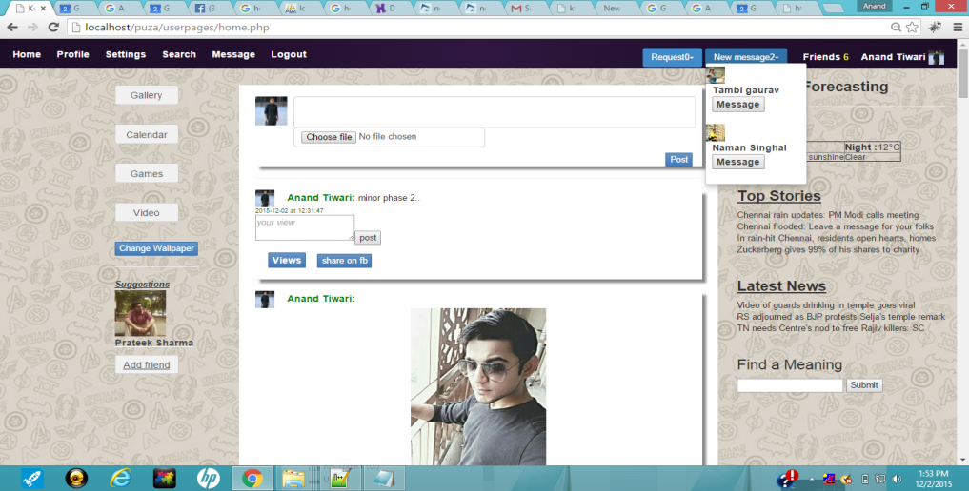

7.2 Profile: It constitutes of user's own post which on scrolling down will show the previous post while the user's photo will remain at same position.

7.3 Settings:

User is given the privilege to change his/her account settings. User can change username, reset password & the existing profile picture.

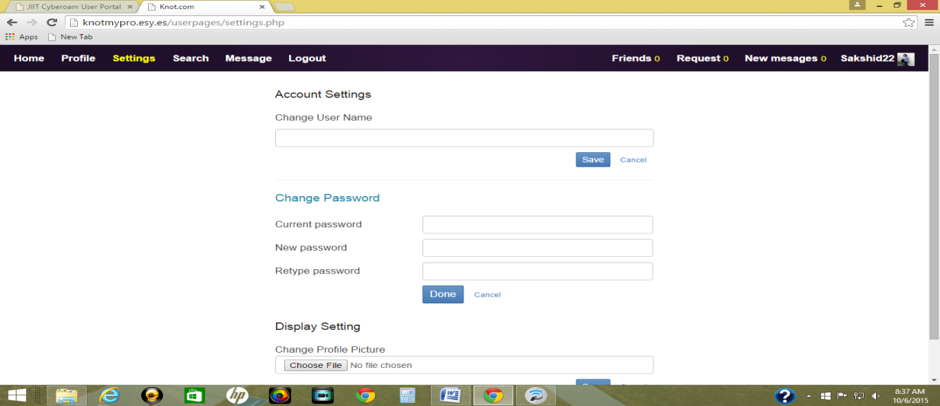

7.4 Search:

In search option, user can search a friend by its username. We have implemented Ajax methodology in searching option which means if you press A, then all the existing users starting with A will appear.

7.5 Message:

One of the very special feature of a social media is a personal message. Here you can send a private message to any of your friends.

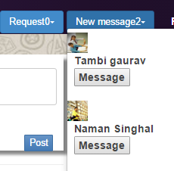

7.6 Logout:

To safely exit from the website

7.7 About:

While visiting your profile there is an about option where you can mention your contact number, address & a brief discussion about user.

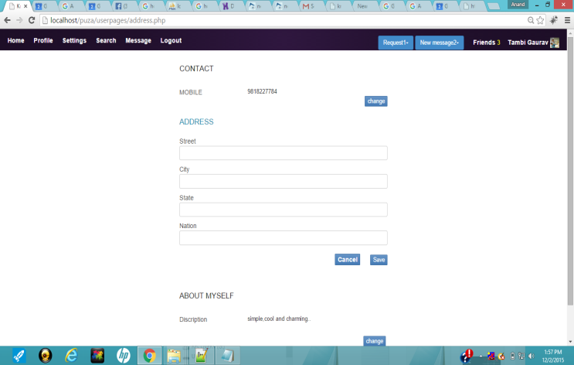

7.8 Friends: It shows the current friend list of the user.

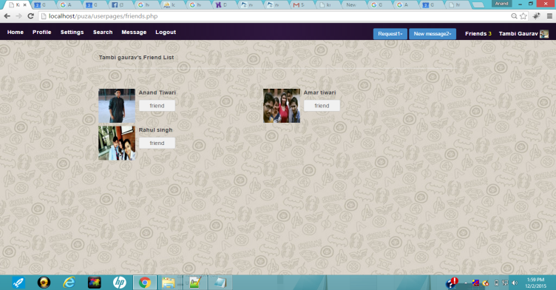

7.9 Request: If you click it, you'll find if there is any new friend request.

7.10 New Message: If there is any new message from a friend, you will find in this menu.

7.11 Username: On the right corner you'll find your username.

8. Additional Features in Phase 2

8.1 Google Mapping: The work on google mapping has been implemented with intense care. One can fetch our own location & can search the new location. The google map will itself takes it to the other location. We'll do it by scrolling to search options. This means one can find the location by checking the address in the about menu.

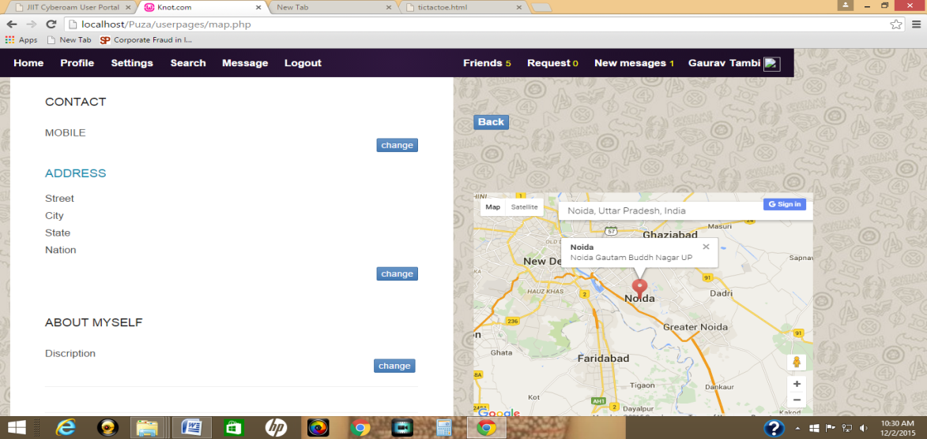

8.2 Share on Facebook

We've implemented this feature in our website that is if we update a post then we are able to share it with on our fb id. This gives us an extension to our social networking website.

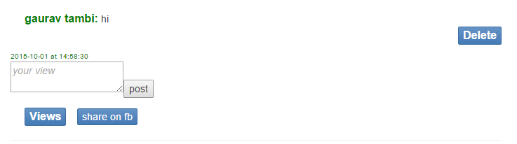

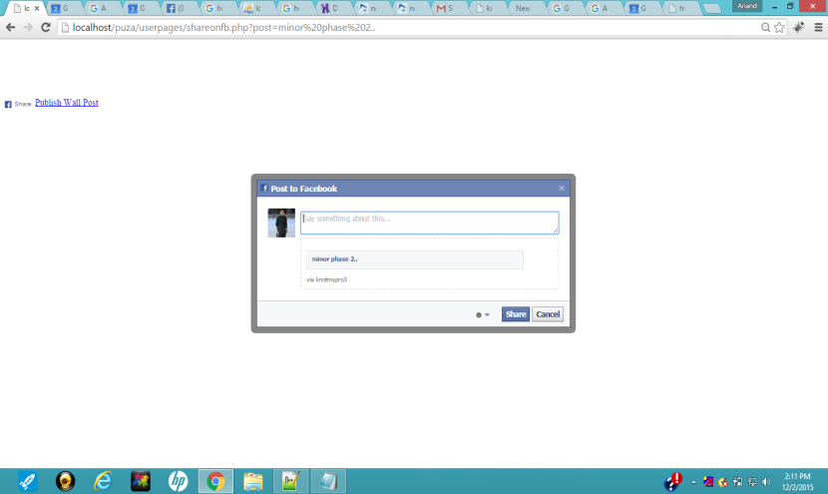

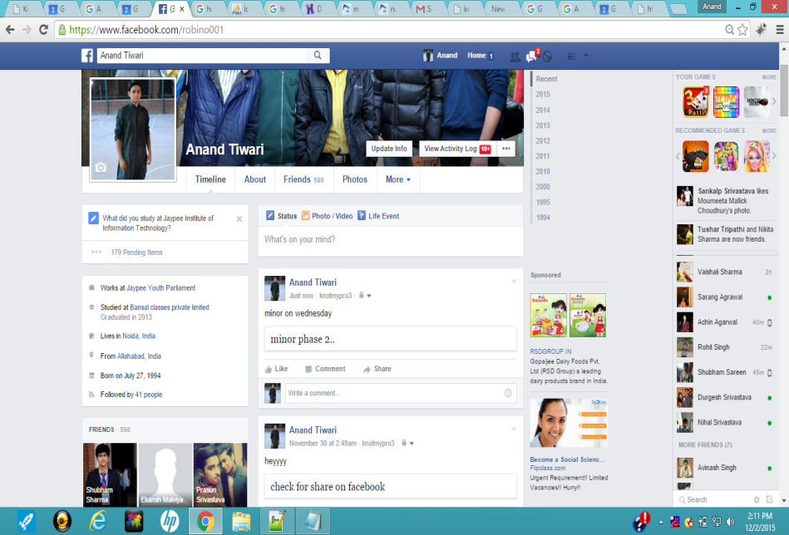

8.3 Youtube Videos

We've add up a feature that while refreshing all the latest videos of youtube will be directly fetched. All we need is to need to select the desired video out of those options. We've been fetching videos via a particular channel on youtube.

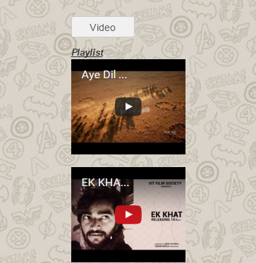

8.4 Game World

We are working on a game world . This lively youth is very fond of internet games & hence we thought of implementing a few popular games in our social networking website. It contains four games namely:

Tic Tac Toe

Pokemon

Maze

Check ur Speed

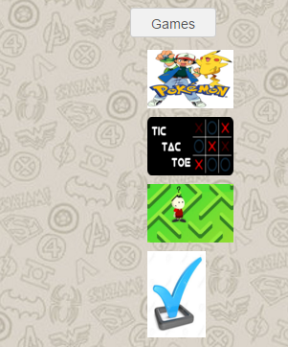

8.5 Galeries

Galaries is again a very substantive feature of awebsite or we can say a website is never complete until & unless we have a good variety of display. We realised this fact & worked on it. We provide this facility to user to add photos to his/her account in gallery. Also a person is allowed to change his/her own wallpaper.

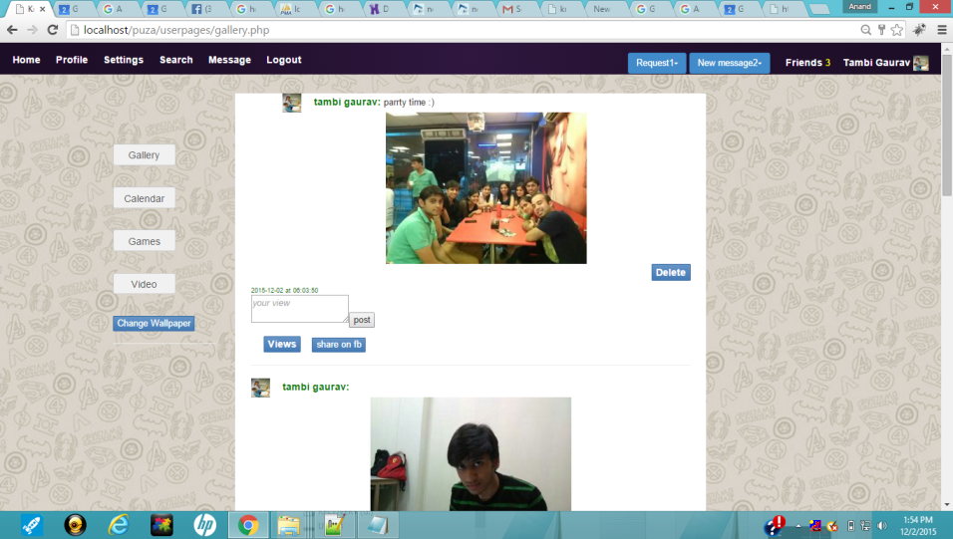

8.6 Calender

A small but surely an imporatnt feature to add up. A calender is picking date, month & year from sysdate( ) & it is automatically updating the required things. There is a facility to jump to the next month or to the next year. We can add up events, birthdays & can set up as a reminder.

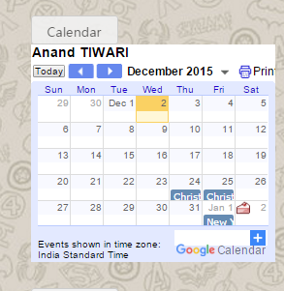

9. Android App

Android module of a website is a gist of any project. Our android app is working on the general requirements of a user that is chatting. It has been made with the help of the android studio. Salient Features:

Made with help of android Studio

Contains Login page

Enables chatting with other users

Can deal with multiple accounts

Worked on interface

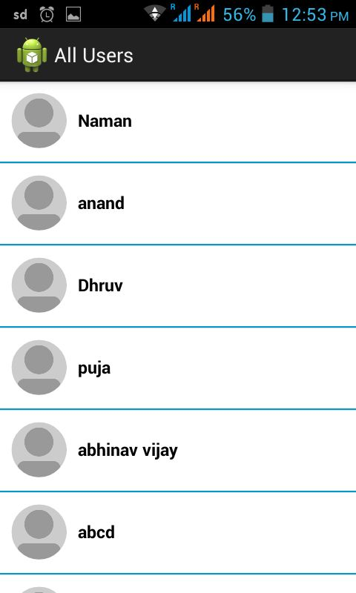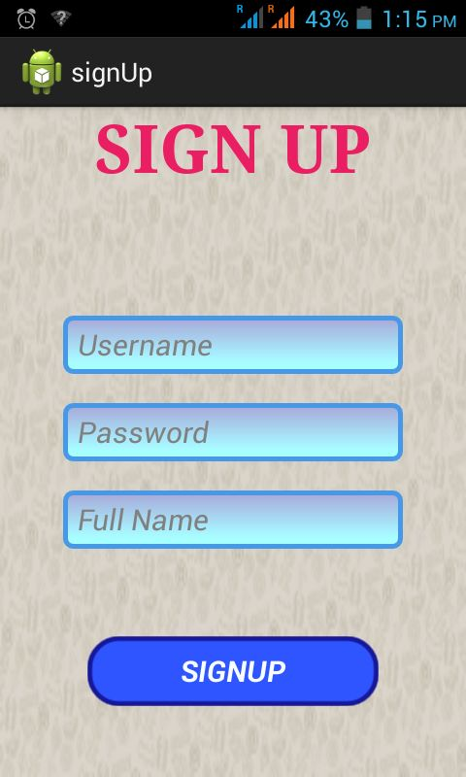

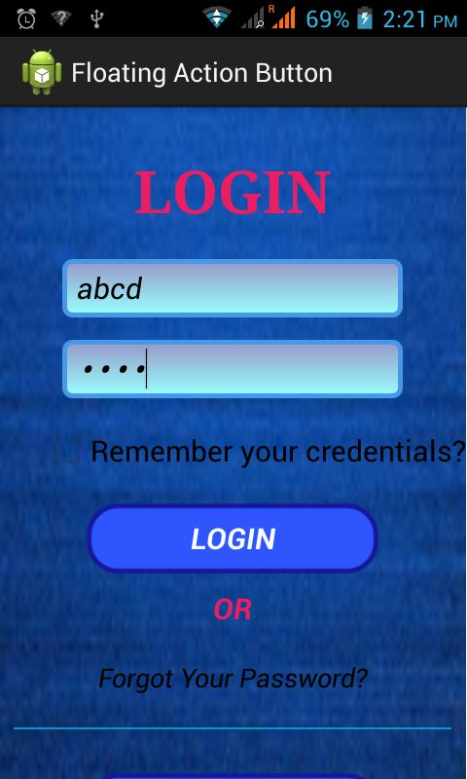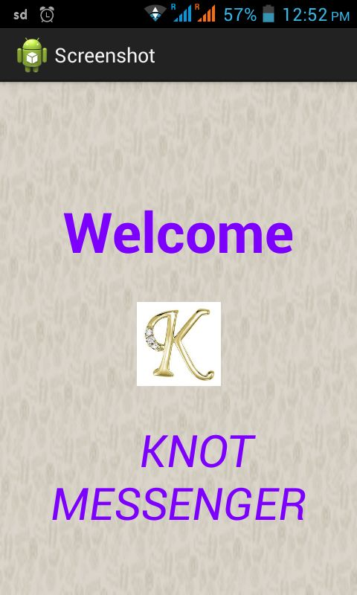

**10. Internal working**

10.1 php, scrapping

* Scrapping is a technique of fetching something from some other webpage into your own webpage. He has achieved this by fetching the latest news article from Times of India website . As soon as you switch to the knot website , you can see the latest news feed on the right corner side. This required him to study the scrapping & crwaling details. Our main objective is to achieve the crawling so that we can import the full news articles & we'll be surely implementing this in future. A glimpse of scrapping news feed has been given below.
* Weather Forecasting: One of the salient feature of this website is to show the present weather of the current city. It fetches the data from internet & shows the current date from system, day & night temperature & the weather conditions.

10.2 Database Handling, Java Script Ajax

One of the most imporatnt feature of a website is the proper organisation. of its daatbase. Database handling includes the working on sql database. He has worked on tables namely

* friends,
* status,
* user master,
* my message,
* view,
* meeting.

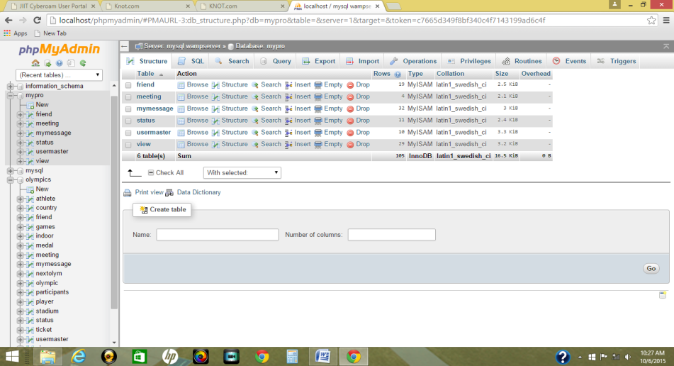

It is operating dynamically which means if someone is making account or if updating an status or say if someone is adding a picture then it will be automatically updated in the database. Also, a huge part of website depends on working on queries which constitutes a major part of the website.

10.3 Ajax : Ajax is a technology where if you type a letter say 'Sa' then automatically all the persons with username 'Sa.....' or to be very precise like 'Sakshi' or 'Sanket' will start appearing on the list. This technology helps in a synchronization of data & easy searching.

10.4 Facebook graph API, Bootstrap

* When the project was set ina direction with agood synchronozation of php coding & database handling, then there was a need of expansion of the website wiyth some new features &, hence, here it comes the use of Facebook Application Interface Program where it provides a platform for login into facebook through knot website. It fetches the specific details of facebook user & saves into our website databse. This expand the functioning of the website. Also, the work is being done to connect it through the gmail & in future we plan to link it with linkedin, instagram, twiiter for the next phase.
* Also, some work is done to bootstrap to improve the functioning if front layout. Bootstrap includes the designing of sign up page, where we have implemented the 6 to 3 ratio in designing the front page. Also, it enhances the layout of the front page.

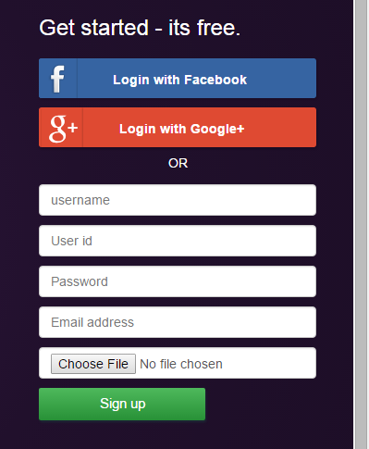

10.5 Google Location, Bootstrap

Adding to the queue one of the most important feature was to implement Google mapping which will let you find the address. It enhances the level of website. Though she prepared it as a separate module but we plan to integrate it in the website before the final presentation. The module helps in setting a meeting of two persons & hence helps in finding the two nearest locations of the persons.

10.6 Bootstrap: Enough work has been done in the internal designing of the website using bootstrap. All the major layout work has been designed with the help of it. Stretching a special focus on settings portion, where she has worked on forms ,i.e., inline forms to implement the change password setting & changing of the username. Apart from it, the fixed location of menu bars is one of the fruit of it.

11. BACKGROUND STUDY AND FINDINGS

This project can only be implemented with the detailed knowledge of html, CSS & javascript. Additionally, it also requires good knowledge of php for designing & linking of databases. We , as a unit, have explored the stuff from internet especially from W3Schools & from variety of books to take this project into a right direction. We have studied php basics & its implementations for completing this phase of the project. Also, we searched for applying scrapping to pick news from Times of India etc. Additionally, we have included the weather report & hence it also required some background study to implement it.

12. DESIGNING IN DETAIL

* URL of project: knotmypro.esy.es
* Online Application: Domain taken from hostinger & editing rights to admin
* Javascipt: CSS,HTML & Java Script are used for fundamental layout of the website. Ajax methodology is also used for searching friends.
* Php: Php is used as a basic language for designing codes for this project.
* Database: MySql is used to handle the various tables required in this project
* Bootstrap: Bootstrap methodoly is used to design the layout of the website
* API: API is used for connecting from different websites like facebook login
* Scrapping: Dictionary meaning & extracting news feed from TOI etc websites
* Google Location: Maps are being used to find the addresses in abouts

13. Webpages

Website consists of the following web pages:

1. Index.php
2. Login.php
3. Home.php
4. Features.php
5. Friend.php
6. Gallery.php
7. Game.php
8. Home1.php
9. Calender.php
10. Inbox.php
11. Indexgallery.php
12. Like.php
13. Status.php
14. Comment.php
15. Profile.php
16. Share_fb.php
17. google_map.php
18. settings.php
19. profile.php
20. update.php
21. dictionary.php
22. weather.php
23. topstories.php
24. latestnews.php
25. videofetch.php
26. about
27. chat
28. search
29. logout .php
30. request.php
31. post.php
32. update_pic,php

14.Project Features

1. Sign In

2. Sign up

3. Login with facebook

4. Update Profile picture

5.Home

1.post

2. views

3.share on fb

4.delete

5.Update profile picture

6.Profile

1.Update own status

2. View/Comment

7. About

1. Contact Details

2. Address

8. Mapping

1.Search

2. Trace typed Location

9.Settings

1.Account Settings

2. Password change

3.Username change

10. Search a friend

11. Message

12. Logout

13. Friends

1.Shows friend list

14. Requests

1. Show pending requests

15. New Messages

16. Gallery

1.Can update pictures

17. Calendar

1. Present date

2. Scroll previous/next month

3.Scroll previous/next year

4.Update upcoming birthdays/events

18. Games

1. tic tac toe, maze, pokemon, cjeck your speed

2. Can play

19.Video

1. Fetch latest video of you tube

20. Change wallpaper

21. Dictionary

22. Weather Forecasting

23. Android Messaging App

Functional requirements based on processes

Customer management

It's a common scenario that a new user registers using the front-end to be able to :

• Check if a username already exists in Database.

• Create new users in Database.

• Modify the information of a user in Database.

User Interface Mock-ups:

Technical Requirements

Web services allows applications to be integrated more rapidly and easily. These characteristics are ideal for connecting functions across heterogeneous systems.

The integration requirements are:

• The system makes calls to the Database web service whenever it requires a synchronization.

• The definition of these web services should not change from version to version to guarantee the integration with different Database versions.

Non-Functional Requirements

These are general requirements that impact in the technical decisions:

• The final system should scale correctly to support high traffic loads.

• Security is key since we are performing commercial translations and dealing with confidential data.

• It is important that all process within Database are automatic.

15.REFERENCES

* W3 schools
* You-tube
* Stack Overflow
* API Facebook Developer